Short summary of the paper: “Atmospheric CO2 measurements and error analysis on seasonal” of X.A. Padin, M. Vazquez-Rodríguez, A.F. Ríos and F.F Pérez.

SUMMARY

Atmospheric molar fraction of CO₂ (xCO₂^{atm}) measurements obtained on board of ships of opportunity were used to parameterize the seasonal cycle of atmospheric xCO₂ (xCO₂^{atm}) in three regions of Eastern North Atlantic (Galician and French offshore and Bay of Biscay). Three selection criteria are established to identify the representative xCO₂^{atm} values:

- Measurements averaged every minutes whose standard deviation exceeded 0.33 ppmv were eliminated . This data filter is inspired by Conway et al. (1994) where only paired-samples displaying xCO₂^{atm} differences smaller than 0.5 ppmv were accepted.
- Differences between consecutive hourly mean of xCO₂^{atm} should be smaller than 0.25 ppmv (Peterson et al. 1986; Gillete et al. 1987). Due to the continuous position shift of the sampling points, the acceptable xCO₂^{atm} difference is arbitrarily set to 0.50 ppmv in the hourly-spaced measurements.
- Following Komhyr et al. (1985), measurements recorded with relative winds (from the ship’s funnel to the atmospheric air inlet) lower than 2 m s⁻¹ were eliminated to minimize contamination by local CO₂ sources.

Subsequently the filtered dataset are fitted to seasonal xCO₂^{atm} curve, an annual increase tendency coupled with seasonal cycle. The obtained curves are consistent with the xCO₂^{atm} time data series from land meteorological stations with the exception of winter minimum growing eastward on Bay of Biscay.

Weekly air-sea CO₂ flux differences (molC·m⁻²·yr⁻¹) produced by the several options of xCO₂^{atm} usually used (on board measurements, data from land meteorological stations and averaged values), were calculated in Bay of Biscay throughout 2003 (Figure). Flux error (mean±std) using fitted seasonal curve relative to on board measurements was minimal whereas land stations and annual means yielded random (-0.07±0.10 molC·m⁻²·yr⁻¹) and systematic (-0.04±0.14 molC·m⁻²·yr⁻¹), respectively. The effect of different available sources of sea level pressure, wind speed and transfer velocity were also evaluated. Wind speed and transfer velocity parameters are found as the most critical choice in the estimate of CO₂ fluxes reaching a flux uncertainty of 2.6 molC·m⁻²·yr⁻¹ during springtime. The atmospheric pressure shows a notable relative effect during summertime although its influence is quantitatively slight on annual scale (0.11±0.07 molC·m⁻²·yr⁻¹). All results confirms the role of the Bay of Biscay as CO₂ sink for the 2003 with an annual mean CO₂ flux around -1.82±1.82 molC·m⁻² ·yr⁻¹.

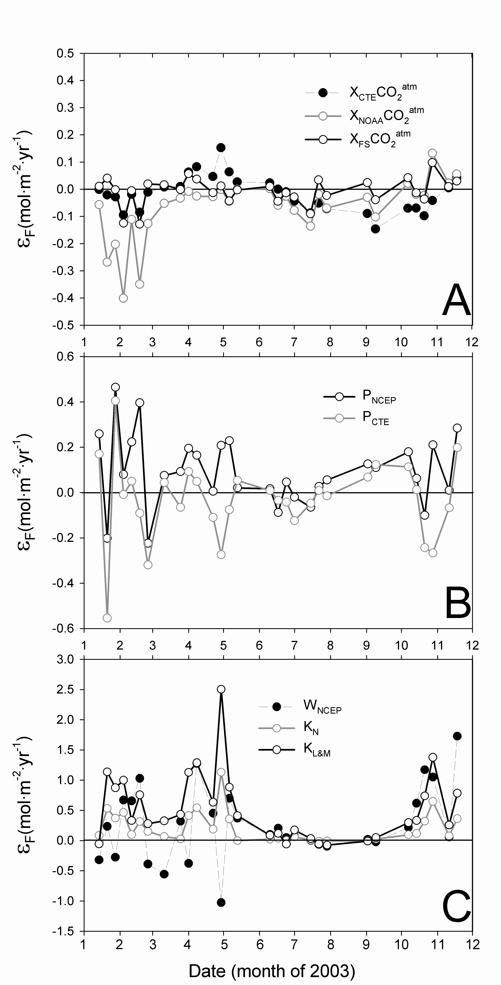

Figure: Errors of the CO₂ flux (ε_{F}, mol·m⁻²·yr⁻¹) in the Bay of Biscay associated with different sources of:
A) Different atmospheric CO₂ molar fractions relative to weekly averages of measured xCO₂^{atm}: seasonal curve fitted from on board measurements (x_{FS}CO₂^{atm}; black line and open circles), latitudinally interpolated curve from NOAA data (x_{NOAA}CO₂^{atm}; grey line) and averaged values (x_{CTE}CO₂^{atm}; dashed line and black circles). B) Sea level pressure relative to in situ measurements: sea level pressure from NCEP/NCAR reanalysis project (P_{NCEP}; black line) and constant value (P_{CTE}; grey line). C) Wind speed relative to wind speed from QuikSCAT satellite (W_{QS}): wind speed from NCEP reanalysis model (W_{NCEP}; black circles and dashed line) and transfer velocity relative to Wanninkhof (1992): Nightingale (2000) (k_{N}; grey line) and Liss and Merlivat (1986) (k_{L&M}; black line).

REFERENCES
Kalnay, E., Kanamitsu, M., Kistler, R., Collins, W., Deaven, D., Gandin, L., Iredell, M., Saha, S., White, G., Woollen, J., Zhu, Y., Chelliah, M., Ebisuzaki, W., Higgins, W., Janowlak, J., Mo, K.C., Ropelewski, C., Wang, J., Leetmaa, A., Reynolds, R., Jenne, R., Joseph, D., 1996. The NCEP/NCAR Reanalysis Project. Bulletin American Meteorological Society 77, 437–471.

Liss, P.S. and Merlivat, L., 1986. Air–sea gas exchange rates: introduction and synthesis. In: The role of air–sea exchange in geochemical cycling. Ed. Buat-Ménard, P., Norwell.

Nightingale, P.D., Liss, P.D. and Schlosser P., 2000. Measurements of air-sea gas transfer during an open ocean algal bloom. Geophysical Research Letters 27, 2117–2120.

Wanninkhof, R., 1992. Relationship between wind speed and gas exchange over the ocean. Journal of Geophysical Research 97 (C5), 7373–7382.

