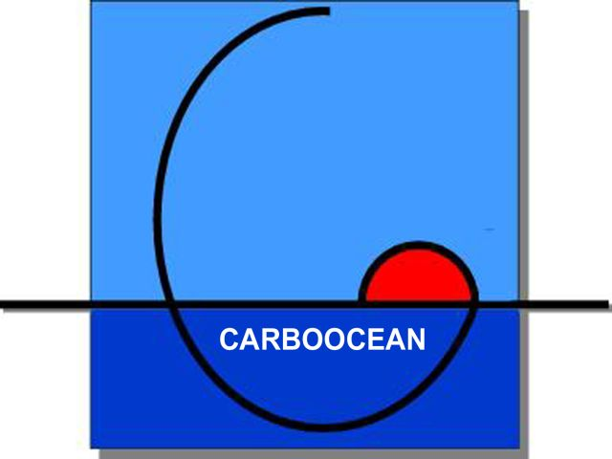 Key experts on marine carbon cycle meets in Bergen

The biggest EU-project on ocean carbon sources and sinks concludes after five years of study that
• the CO₂ uptake in the North Atlantic and the Southern Ocean appears to be reduced. This potential decrease in CO₂ sink and the underlying mechanisms must be observed further
• the carbon cycle climate feedback re-enforces climate change as shown by Earth system models
• ocean acidification is happening

Since the onset of the industrial revolution, mankind has increasingly released CO₂ to the atmosphere, which significantly contributes to human induced climate change. The atmospheric CO₂ content would be higher if it was not for nature’s ability to absorb CO₂. At present about 25% of annual CO₂ emissions is absorbed by the ocean. The CARBOOCEAN-project, which is coordinated by the Bjerknes Centre for Climate Research, is dedicated to improve quantification of the oceanic uptake of anthropogenic CO_{2.} More than seventy scientists in the project meet in Solstrand outside Bergen next week to assess the results.

In considerable areas of the North Atlantic and the Southern Ocean the surface CO₂ partial pressure has temporarily increased faster than that in the atmosphere, which indicates a decrease in the ocean CO₂ sink.

Future scenarios with coupled ocean-atmosphere-land models show that the carbon cycle climate feedback re-enforces climate change. Recent model runs show that atmospheric CO₂ concentration by the end of 21st century will be 6 to 40% higher than previous estimates. Emission targets for CO₂ need to be adjusted accordingly.

A consequence of absorption of human-produced CO₂ in the oceans is acidification. Measurements show that the pH value of seawater is sinking. Model results show consequences of ocean acidification at the ocean floor. Mesocosm experiments show the reaction of ecosystems for sinking pH.

The established North Atlantic carbon observing system delivers CO₂ flux measurements with unprecedented accuracy. Cutting edge observational data syntheses on global surface ocean CO₂ (most comprehensive in the world!) and Atlantic 3-D carbon data have been carried out with international colleagues in a truly worldwide effort.

Time/Place: 5-9 October, Solstrand Hotel & Bad, Os, Norway
Contact person:
Prof. Christoph Heinze, CARBOOCEAN project director, University of Bergen and Bjerknes Centre for Climate Research, heinze@gfi.uib.no, mobile +47 975 57 119.

Facts/CARBOOCEAN
Funding: EU’s 6th Framework Programme, 14.5 million € over 5 years.
Coordinating institution: Bjerknes Centre for Climate Research in Bergen, Norway.
Partners: Consortium consists of 50 international research groups from Belgium, Denmark, France, Germany, Iceland, Morocco, the Netherlands, Norway, Poland, Spain, Sweden, Switzerland, United Kingdom, Canada, and the USA.

More information at: http://www.carboocean.org/

