Publishable Executive summary: Integrated Project “CARBOOCEAN” contract no. 511176 (GOCE)

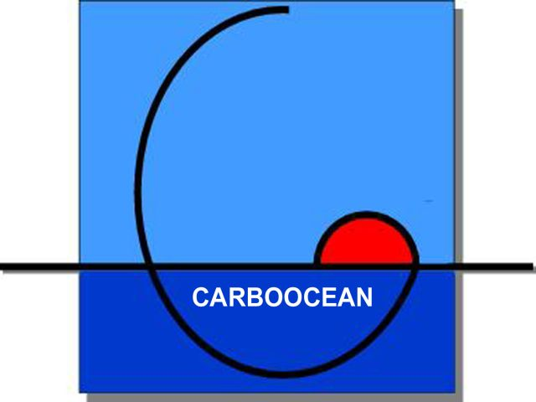

Main project objectives of CARBOOCEAN
The main aim of this Integrated Project is to reduce the present uncertainties in the quantification of net annual air-sea CO₂ fluxes by a factor of 2 for the world ocean and by a factor of 4 for the Atlantic Ocean. The IP will deliver description, process oriented understanding and prediction of the marine carbon sources and sinks with special emphasis on the Atlantic and Southern Oceans on a time scale –200 to +200 years from now. Specific objectives are:

1. Description and quantification of the CO₂ air-sea exchange on a seasonal-to-interannual scale for the Atlantic Ocean and the Southern Ocean

2. Quantification of decadal-to-centennial large-scale Atlantic and Southern Ocean carbon inventory changes

3. Quantification of the carbon sources and sinks at the European regional scale
4. Identification and understanding of biogeochemical feedback mechanisms which control marine carbon uptake and release
5. Integration of carbon observations into an integrated prognostic modelling framework

Coordinator contact details
Christoph Heinze (Project director), Andrea Volbers (Scientific project manager)
University of Bergen, Geophysical Institute and Bjerknes Centre for Climate Research
Allegaten 70, N-5007 Bergen, Norway
Phone: +47 55 58 98 44 Fax: +47 55 58 98 83
Email: christoph.heinze@gfi.uib.no, andrea.volbers@bjerknes.uib.no

Project website: http://www.carboocean.org

Contractors involved (continued on next page)
1 | University of Bergen, coordinator | Norway
2 | Université Libre de Bruxelles | Belgium
3 | Alfred Wegener Institute for Polar and Marine Research | Germany
4 | Leibniz-Institut für Meereswissenschaften Kiel | Germany
5 | Consejo Superior de Investgaciones Cientificas | Spain
6 | Laboratoire de science du climat et de l`environnement | France
7 | Université Pierre et Marie Curie, Paris | France
8 | Netherlands Institute for Sea Research | Netherlands
9 | University of East Anglia | United Kingdom
10 | Université de Liège | Belgium
11 | Universität Bern | Switzerland
12 | Max-Planck-Institut | Germany
14 | Technical University Hamburg-Harburg | Germany
16 | University of Bremen | Germany
17 | National Environmental Research Institute | Denmark
18 | University of Las Palmas Gran Canaria | Spain
19 | Université de Bretagne Occidentale | France
20 | Centre national de la recherche scientifique | France
22 | University of Perpignan | France
23 | Marine Research Institut | Iceland
24 | Institut National de Recherche Halieutique, Casablanca | Morocco
25 | Rijksuniversiteit Groningen | Netherlands
26 | Netherlands Institute of Ecology | Netherlands
28 | Nansen Env. and Remote Sensing Center | Norway
29 | Norwegian Institute of Air Research | Norway
31 | Institute of Oceanology of the Polish Acedemy of Sciences | Poland
32 | University of Gothenburg | Sweden
33 | MetO (UK) Hadley Centre for Climate Prediction and Research | United Kingdom
34 | Southampton Oceanography Centre | United Kingdom
35 | University of Essex | United Kingdom
36 | FastOpt | Germany
37 | Intergovernmental Oceanographic Commission of UNESCO | France
38 | NILU Polska Ltd. | Poland
39 | Philippe Saugier ingenieur-conseil | France
44 | Trustees of Princeton University | USA

Work performed and results achieved so far
During the first year of the project the observational programmes were successfully initiated and carried out from month 1 on. The major threedimensional modelling work started by month 7. Major scientific achievements of the project’s 5 core themes within the first project phase (“description” phase) during months 1-12 are:

Core theme 1 “North Atlantic and Southern Ocean CO₂ air-sea exchange on a seasonal-to-interannual scale”
A surface ocean CO₂ observing system based primarily on Voluntary Observing Ships has been implemented for the Atlantic. This network represents a major achievement for Carbo-Ocean: the first ever operational multi-ship CO₂ observing programme, covering an ocean basin and reporting regularly and rapidly into a data base. Considerable return of CO₂ data from the Southern Ocean in 2005 was achieved from a Carioca buoy (released Jan 2005), and several research vessels (R/V Polarstern,, R/V Las Palmas, RRS Discovery, and R/V Marion Dufresne.

Core theme 2 “Detection of decadal-to-centennial Atlantic and Southern Ocean carbon inventory changes”
The focus has been on data collection, data reporting and data assembly. Some significant new data sets have been collected and metadata for these data sets have been contributed to the CARBOOCEAN data portal. This includes some of the very first high-quality data from the Arctic Ocean as well as the Mediterranean Sea. In addition, data that can be directly compared with the earliest available high quality inorganic carbon data have been collected and are under analysis. Model results from 4 coupled interactive carbon cycle climate models have been provided and compared with historical data for surface pCO₂ and anthropogenic carbon using a newly developed interface for model-observation intercomparison.

CARBOOCEAN Core Themes 1-5, new results achieved and particular linkages
between the themes

Core theme 3 “Carbon uptake and release at European regional scale”
Data compilation and field work were carried out. Data bases on coastal calcification, coastal CO₂ fluxes and North-Sea-relevant carbon cycle data have been established. Ship expeditions in the North Sea and the Starit of Gibraltar were carried out. Underway measurements of the partial pressure of CO₂ have been made on regular North Sea ship routes. A demonstration study on data assimilation of ocean data for improving estimates of terrestrial CO₂ budgets was performed.

Core theme 4 “Biogeochemical feedbacks on the oceanic carbon sink”
An assessment of the seasonal and interannual variability of the air-sea CO₂ flux in the Atlantic Sector of the Barents Sea was completed. A new coupled physical/biogeo-chemical/ecosystem model development of the main tool for Southern Ocean studies was developed. The response of dominant phytoplankton groups to CO₂ induced changes in carbonate chemistry was addressed during the first CARBOOCEAN mesocosm experiment (PeECEIII). During the Beringia expedition, the icebreaker Oden crossed the Arctic retrieving high quality carbon cycle tracer measurements.

Core theme 5 “Future scenarios for marine carbon sources and sinks”
Four coupled carbon cycle climate models have been integrated forward to present day conditions, and 2 of them already until year 2100. The most important results is, that the two models, which already reached year 2100 showed both a reinforcing of climate change due to accounting for the carbon cycle climate feedback. The work on purposeful CO₂ storage in the ocean has progressed through development of pressure tank techniques to experimentally determine the near field behaviour during potential CO₂ injection into the deep sea water column and modelling studies (CO₂ spreading in the near field, preparation of far field studies).

Expected end results
-Short term assessment of net air-sea CO₂ fluxes
-Large scale assessment of the ocean carbon storage
-Assessment of the western European contribution to the oceanic CO₂ uptake
-Assessment of the role of biogeochemical feedbacks for oceanic CO₂ uptake
-Assessment of future marine CO₂ uptake kinetics based on models and data

Intentions for use
The results of CARBOOCEAN will contribute to guiding informed policy decisions about climate mitigation and adaptation strategies. Data collection, data compilation, and modelling systems will be exploited in more sustained monitoring systems of the ocean carbon cycle within GMES/GEOSS (Gloal Monitoring for Environment and Security http://www.gmes.info/,
Global Earth Observation Ssystem of Systems http://www.epa.gov/geoss/index.html).

Impact
The main impact of this integrated project is expected concerning:
- clarifying the impact of European emissions on a regional and global scale
- input into international negotiations
- input into climate policy strategies

Publishable results of the plan for using and disseminating the knowledge
-dissemnination through web site (information for the general public, the press, interested scientists and internal web site for CARBOOCEAN scientists)
-dissemination through annual thematic dissemination research seminars (e.g. “Quantification of the Atlantic CO₂ source/sink” during the first CARBOOCEAN annual meeting; yearly CARBOOCEAN summer schools, e.g. “Measurement methods for the carbon system and related tracers in sea water”)
-scientific publication in peer review journals (more than 80 publications during the first year, see Knowledge Management Plan for further details)
-scientific conferences (participation at international conferences and special sessions devoted to CARBOOCEAN and CARBOOCEAN topics at international conferences, such as e.g. the EGU in Vienna)
-general publicity material (general brochures and posters, CARBOOCEAN project summary available in 17 languages, CARBOOCEAN tasks and introduction as part of the CarboSchools booklet that can be downloaded from an interactive website offering good quality materials both on scientific contents and teacher-scientist partnership methodology)
-film recordings and documentary (CARBOOCEAN topics and CARBOOCEAN scientists on various national TV programs; professional film recordings of CARBOOCEAN experiments and events done by Univisjon, Partner 1, with view to a documentary)

