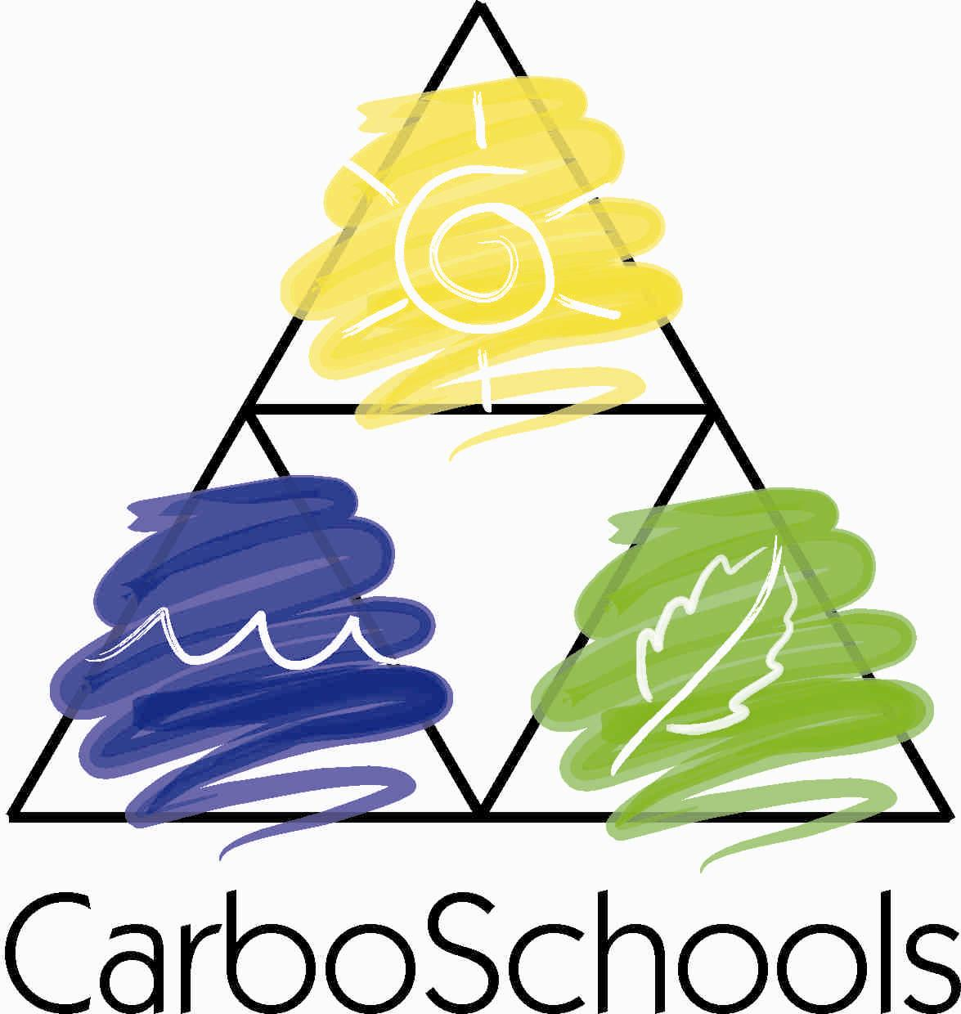

TEACHER-SCIENTIST PARTNERSHIP GUIDE
TEST VERSION FOR PILOT PROJECTS 2005-2006 – NOT YET FINALISED
(to be improved in subsequent years)

Contents

1. Aims of this guide
2. What shall students do and gain with a CarboSchools project?
3. What does “Teacher-Scientist partnership” means?
3.1 Contributions: who does what?
3.2 Benefits: who gains what?
3.3 How to find each other?
3.4 Time & multiplying effect
4. Educational goals & link with the curriculum: interdisciplinarity, science & citizenship
5. A few practical tips
5.1 For teachers
5.2 For scientists
5.3 For both
6. An additional possible actor: university students
6.1 Main tasks of university students
6.2 Main tasks of supervisor
6.3 Economy
7. Resources for your projects
7.1 Funding
7.2 CarboSchools website
7.3 Young reporters for the environment
7.4 Globe

Appendix 1: CarboSchools project identification sheet
Appendix 2: general principles about science education
Appendix 3: two examples of projects
Appendix 4: examples of links between CarboEurope/CarboOcean science & syllabus

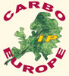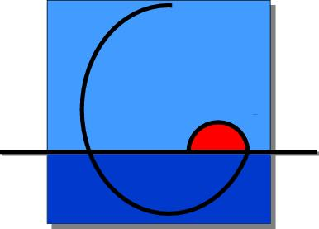
This publication has been funded by the EU, CarboEurope & CarboOceans Integrated projects
(contracts GOCE-CT-2003-505572 and 511176-2)

1. Aims of this Guide

This document is intended as a practical guide to (i) secondary school teachers from all disciplines and (ii) scientists from the global change community (in the broad sense: research scientists, PhD students, technicians…) who would together like to implement a CarboSchools project.

A co-operation between teachers, students and scientists is a challenge for all parties involved. The most common problem is taking the first steps and avoiding the mistakes that often prevent new projects from getting off the ground. Here, practical advice is given based on experience gathered in co-operations between schools and research institutes in several European countries.

The ultimate goal of this guide is to foster new co-operations that are able to promote the science of global change in secondary schools in contribution to citizenship development.

2. What shall students do and gain with a CarboSchools project?

CarboSchools projects can be initiated at any moment for a duration between a few weeks and a whole school year with classes or groups of voluntary students (ages 12-20) under the supervision of a team of teachers, and in partnership with a global change scientist.

Every project is unique and has its own characteristics; however we suggest:

- One fundamental principle: the students are the main project actors (project teaching is not about “teaching” knowledge to a more or less passive class (top-down) but about putting groups of students in active situations where they “learn” knowledge & skills). Depending on goals, constraints and curriculum flexibility, project work is spread between normal lessons, dedicated project hours in the timetable, and outside school hours.

- Five key objectives:
- discovering and better understanding scientific research, its methods and its results
- applying this knowledge to the problem of global change
- improving skills to deal with transdisciplinarity and complexity
- increasing the awareness of local implications of global change: how do you, your family, your school and your town contribute to the problem and to solutions? How global change may affect your life and your future?
- Acting in the society and sharing the results of your project with a wider public

To achieve this, you may propose various types of activity to your students:
- ask yourself questions, and develop your own project focus – i.e., your own way of tackling the question of global change, taking as a starting point what affects and concerns you directly;
- get to know “your” scientist through personal meetings and discussions
- follow his/her research, experiments, and try things on your own. Take measurements and perform other hands-on experiments on physical phenomena, greenhouse effect, climate & weather etc.
- find and analyse information obtained beside document-based sources (e.g. Internet) and resource persons (journalists, researchers, associations, elected representatives, technicians etc.)
- cooperate with other schools & students in Europe, for example to share information, experience, make penpals and why not, visit each other.
- organise information and develop a product: website, booklet, CD-ROM, newspaper article, game, play, presentation, debate evening, etc.
- disseminate your results around your school, in your town (and at the European level through the CarboEurope and Young reporters for the environment websites)
- take action, i.e., thinking up and looking for solutions to contribute in reducing greenhouse gas emissions within your family, at your school or college, in your town, etc.

At the beginning, some students may find project work heavy and not easily related to the curriculum; but in a successful project, students progressively develop ownership, become very eager and can achieve incredible things. You may highlight many opportunities of benefits for them:
- do experiments;
- learn about scientific discovery process;
- participate in “real” scientific research;
- learn about careers and what scientists do;
- test if science "suits" you;
- make learning fun;
- sense of accomplishment - feel proud of what you achieve;
- gain in self-confidence by being taken serious by scientists;
- apply foreign language skills;
- encounter and understand science that is relevant for society; prepare for making informed choices on policy decisions as adults.

3. What does “Teacher / Scientist partnership” mean?

A partnership between school and research might take many possible forms depending on persons and projects involved, material constraints, etc.; but in all cases, the idea is to create a relationship between scientists and teachers to enable young people to gain practical experience of research (whether in a laboratory, through field work where possible, or simply in discussion sessions). Ideally, this partnership should be as direct as possible, avoiding bureaucratic obstacles and hierarchies.

Preparation, planning, definition of objectives, definition of age group are done as much jointly as possible. When working well, a teacher-scientist partnership may be used over several years with different groups of pupils.

Examples of activities that can be conducted:
- Real-time experiments (in lab, on field or at school)
- Site visits (but real visits with scientists, not through public relations)
- Topical lectures, debates
- Access to research results (e.g. real data on the internet)
- Follow-up communication by e-mail (question/answer with students)

It should be stressed, however, that partnership means contributions from but also benefits for all parties, as shown below; it should be balanced, otherwise it will not last.

3.1 Contributions: who does what?

Roles of teachers:
- project coordinators – shape & structure contents and methods;
- prepare students with the required background knowledge;
- mediators between students (and their syllabus-requirements) and scientists (and their specific scientific agendas);
- assess the students’ work as much as possible as part of their formal school results
- invite scientists to participate;
- evaluate the success of the project by gathering feedback from the students and evaluating the project’s impact on their performance in the classroom;
- mediators between information/knowledge and data/facts from experiments
- need to identify + communicate to students the relevance of the project within the curriculum

Roles of scientists:
- provide the state-of-the-art science and explain the research background of the project work;
- ideally: the "real life" enthusiastic example, "role model" for students;
- project partners (do not replace the teacher);
- provide resources (apparatus, equipment, publications, figures), publish new ideas/results and offers on website
- encourage students to formulate their own ideas and to discuss their work;
- set examples (how to give a good talk/presentation; how to write an experiment-protocol, ...)
- need to identify + communicate to students the relevance of the project (general relevance for society)

3.2 Benefits: who gains what?

Benefits for teachers
- gain access to experiments and demonstrations that would not have been possible in the classroom; in some countries there is little chance for doing practical experiments in the classroom, or if there is, the equipment may be outdated. By teaming up with a research institute, avenues for work in the laboratory or in the field are opened.
- bring “fresh air” in the classroom; for the students, scientists have a different status than the usual teacher;
- increase the students’ motivation in science classes and add life to the dry theory of textbooks
- fulfil new curriculum requirements (eg transdisciplinarity, project work)
- increase the relevance & quality of your teaching, put more in evidence the links between syllabus & society issues
- Learn more about research process and the scientific method, access research quality data, satisfy research interests, update factual knowledge;
- train the students’ social skills (making and keeping appointments, working in teams, ...)
- increase the attractiveness of your school both for students and parents by offering "added value";
- gain experience in interdisciplinary group work with other teachers
- through European cooperation, learn from teachers from other countries and make your pupils learn foreign languages in the frame of real communication situations
- as an overall result, enjoy an enthusiastic and motivated student body to work with
Benefits for scientists
- fulfill outreach obligations by EU or national projects;
- demonstrate active outreach work as basis for new research proposals requiring public funding;
- fulfill an educational obligation of your institution;
- recruit students;
- help to improve the training of students entering undergrad programs;
- in some research areas, students can help you to collect data, samples, make field observations;
- gain voluntary help for open days or exhibitions of your research institution, or a web-site;
- refresh your memory on the basics (and be surprised to find out how much you have forgotten);
- increase your understanding of the needs/constraints of teachers;
- promote the idea that “science is part of life”;
- bring diversity to your institution’s programme;
- Professional development:
  - improve your communication skills related to a specific target audience (here young people) with the help of teachers; learn from the pupils’ spontaneity to identify the key questions for normal people.
  - improve your teaching at all levels; profit from the teacher’s experience in motivating students, in producing teaching resources (eg small experiments etc.) that you can then use in university teaching
- escape the routine and have fun;
- profit from teachers and students as multipliers for your scientific message;
- In the frame of a well structured school project, gain in relevance and efficiency: you are not just giving a punctual talk to more or less interested & prepared pupils, you are supporting a process in which young people will be not only beneficiaries of this exchange, but also intermediaries for a wider public to which they will pass on what they have learnt.
- raise environmental awareness directly through young generations, not just through policy-makers

3.3 How to find each other?

If you are a scientist and don’t have existing contacts with schools, you can use existing channels such as teacher associations, local science education schemes, science museums, school authorities, national operators of Young reporters for the environment.

If you are a teacher, you wish to get in touch with a scientist and if you do not have any contact for the moment: send a short presentation of your project (goals, workplan considered, teachers involved, expectations regarding partnership with a scientist) to Philippe Saugier, CarboSchools coordinator: saugier@netcourrier.com.

Scientists will always find a school nearby, but not all schools interested in doing such projects will necessarily find motivated scientists in the neighbourhood. If it proves too complicated or impossible:
- try to find scientists outside CE/CO networks (eg through local industry, local science education organisations, science museums etc.)
- use on-line resources, e.g. follow-up of expeditions (less engaging and rewarding, but also less time-consuming)
- initiate a Globe or YRE project (see below)

3.4 Time & multiplying effect

Time will always be a limiting factor. Teachers and scientists have in common that they have little time to spare and that involvement in a project of this kind goes beyond their respective basic duties. The minimum amount of time to spend will really depend on both partners. Most scientists, when not already engaged with a school, will be happy to spend a day or two per year. PhD students may sometimes give more. A few scientists may be able to spend more time on these projects. Some activities may be short and intensive (eg 1 day in the field), others more sustained for a longer period (e.g. monthly meeting and follow-up through e-mail or phone).

The multiplying effect is therefore crucial: if the project involves local communication activities (eg exhibition, website, cd-rom, newspaper, conference…), many more people will benefit (families, rest of the school, city etc.), giving higher impact for the time spent by scientists & teachers. Make your results visible and recognised by parents, school authorities, research institution, press etc. Use existing channels & opportunities: open days of school & institute, shops, local science museum etc. Make pupils inform the local media, invite journalists on special occasions etc.

4. Educational goals & link with the curriculum: interdisciplinarity, science and citizenship

Experimental research links up biology, chemistry, physics etc. and is therefore cross-curricular by nature: dealing with contemporary research automatically involves interdisciplinary approaches throughout science subjects. Furthermore, in the context of global change, interdisciplinarity goes far beyond linking up science subjects with each other: the whole issue of relationship between human societies and the environment, and between industrialised and developing societies is at stakes. Global change is much more than an scientific issue: it is a complex society issue which concerns and affects us all.

CarboSchools projects are therefore deeply interdisciplinary and may be referred to science education, environmental education, sustainable education as well as citizenship education.
- in scientific subjects, they provide occasions for discovering and practising scientific method, for promoting the human dimension of science through meetings with researchers, and for strengthening disciplinary learning by putting in evidence the links with one of the major stakes of the 21st century. Appendix 2 shows the specific links between syllabus in chemistry, physics & biology and CarboEurope/CarboOcean science.
- in other school subjects, they provide opportunities for articulating field investigations, analysis and production of documents, oral and written expression in mother and foreign tongue with scientific, economic, social and political issues.
- in a transversal way, they strengthen critical and reflective thinking as well as horizontal skills (autonomy, team work, initiative, oral & written communication etc.)

Learning science is thus here far from being the only goal. Projects may be structured around a variety of learning goals, from disciplinary/knowledge-based to interdisciplinary/skills-based:

Disciplinary goals  SCIENCE / KNOWLEDGE  Content-based  .  .  .  .  .  .  .  .  Interdisciplinary goals  CITIZENSHIP / SKILLS & SYSTEMIC THINKING  Process-based | Learning scientific notions  Changing representations of science  from boring to exciting, from theoric to practical, from abstract to concrete  Connecting notions with a big society challenge: global change  Understanding complexity  Developing the desire and capacity to learn by oneself, to understand the world, to act in the society

CarboSchools goes beyond learning science in a different way and transmitting new information to young people from research: the ultimate goal is to provide students with knowledge and skills for “informed choices” as consumers and future citizens.

5. A few practical tips

5.1 For teachers
- Try to involve language – humanities - economics teachers (explain the benefits to your colleagues)
- Before timetable are made (generally June), raise institutional support by proposing this project among the priorities of your school. It will help to secure some flexibility and space in the timetable, to obtain school hours from your headmaster
- Organise yourself in advance to be able to acknowledge project work in students assessment (otherwise project work will be regarded as a peripheral, out-of-school activity)
- Use specific curriculum requirements for project work (eg professional practice)
- Give scientists some information about curriculum and how own their research fits in
- Prepare your students to the sessions with the scientists, and take part actively yourself (you are co-educating, not transferring your education responsibility to someone else)
- Give feedback to scientists after their interventions (was it satisfying, useful?)

5.2 For scientists
- Involve PhD students when possible: they are closer in age, deeply involved in experimental science, and need to develop their communication skills as part of their training.
- Remember that what schools mostly need/want is not your scientific knowledge, but your skills in doing science / i.e. in experimenting: planning– obtaining evidence – analysis – evaluation
- If useful for institutional backup, ask a support letter from CE/CO coordinator
- When you work with school students:
  - Tell stories, make it fun!
  - Treat the students like young colleagues, take them and their work serious
  - Don’t be transmissive. Remember the old Indian saying: “what my ears hear, I forget it; what my eyes see, I remind it; what my hands do, I understand it”. Try to link notions (what one needs to know to understand) with action (what we do concretely on the field)
  - Avoid scientific words and in any case don’t use them without explaining them; try to use everyday language as much as possible. Train yourself with a non-scientist before speaking with pupils!
  - Try to articulate the specific with the general, put in evidence why your own specialised research is relevant & important to the wider global issue. Three key-levels may be considered:
a) General overview of global change research: what we know and what we don’t know;
b) European Integrated Project-level: what is CarboEurope (or CarboOcean)? What are the big questions behind & related activities? Why doing research at the European level?
c) Your own research: what specific question are your working on? How do you look for answers? How do you collect data? How do you analyse & exploit results?
(the CarboSchools educational booklet may help you for the two first levels)

5.3 For both
- Start small, keep it simple, prefer limited things you are sure to achieve rather than big things you may well not manage – and when you get experience and established links with enough resource persons, you may do more.
- Remember that school projects planning is always easier between Christmas & Easter for the next school year.
- To develop a successful relationship:
- start wit a briefing of specific roles and respective expertise (who is expert of what among teachers & scientists)
- Agree appropriate ways of communicating with each other during the project
- Be careful that both are active (avoid situations where teachers stay aside when scientist is with pupils)
- For a successful start:
  - Bring examples from past successful projects you’ve been involved in
  - use the natural fascination of students (children) for some subjects (eg ocean, animals etc.)
  - start from what the people understand or witness directly, to come to global change & complexity progressively
  - Use the means you have and don’t wait for eventual funding, things can get more elaborated later on
  - Get concrete, go out and do real measurements as early as possible in the process
  - Allow individual student(s) to follow your work for a couple of days

6. An additional possible actor: university students
When relevant and possible, university students can play a very useful role- be it science students interested to get an experience of research as well as of teaching; communication/journalism students interested to experience research; future teachers and educators, etc.

By their age and function, university students are at the cross between teachers, scientists and school students; and with potentially more availability than the scientist and the teacher.

Their supervisor can be someone from the lab (in particular when involved in teaching themselves) / from the staff (eg public relations people), or from another university department (eg. didactics) or teacher training institute.

With an Erasmus grant, when language is not too much an obstacle university students could even be sent to carboschools projects with other CE/CO partners in Europe.

The task listed below have been designed for students from the environmental education degree of the University of Tuscia, Italy- but may be of use or inspiration in other contexts.

6.1 Main tasks of university students
- Fundamental role: to develop the educative message behind the scientific content (i.e in the table p.6, “going down” from science to citizenship)
  - try to involve teachers from other subjects (organising meetings, identifying links with the curriculum in various subjects & activities relevant to these links)
  - evaluate the project from the environmental education point of view: behaviours & skills
  - thesis: the memory of the project (can be used in subsequent years to make comparisons)
  - coach the European cooperation on a day-to-day basis
  - make sure that “taking action” is included in the students’ activities
- Help with the “end-product” (coordination, activation of pupils, technical finalisation)
- Help with fund-raising for the school project they’re involved in (finding relevant sources & writing proposal)

6.2 Main tasks of supervisor
- Inform & recruit university students
- Follow them, give advice
- Organise teacher training for the teachers involved- to make respective roles clear + planning the project
- Fund-raising
- Keep tracks of the thesis/projects results
- Make European cooperation between projects happen / give the initial impulse
- Promote Erasmus projects

6.3 Economy
- university students basically cost nothing (this is part of their training)
- living costs (local travel & meetings)
- some materials/equipments (games…)
- regional event when relevant/possible (1-day public event with all participants from projects of a same region)

7. Resources for your projects

7.1 Funding

In most places local funding is available for innovative science education projects of that sort (from municipalities, regional authorities etc.). If you get funds, make a special bank account to limit accountancy complications.

To promote European school partnerships, the EU offers Comenius funding for preparatory visits and cooperation projects:
(see http://europa.eu.int/comm/education/programmes/socrates/comenius/index_en.html ).

Scientists are quite used to apply for money and can be very helpful in raising funds for your project.

Other opportunities worth to mention:
- Make an agreement that energy savings resulting from your project will benefit your project budget.
- Use of equipment: basements of research institutions often hide good equipments no more used which can be lend (sometimes even given) to schools
- Propose an agreement with the public relations department of your partner scientist’s institute to sell them (or make them finance) the products from your project: eg exhibition, brochure…
- In special cases, scientists may be interested to pay a group of students in exchange of a specific job useful for science- like observation or data acquisition activities.

7.2 CarboSchools website

www.carboschools.org offers you access to:
- An educational booklet proposing an introduction to research challenges, questions and methods
- Depending on opportunities, follow-up of scientific expeditions (in particular oceanographic cruises) with introductory material and exchanges with scientists in mission.
- The CarboSchools on-line lab where you can
  - read & publish resources for school projects (i.e. description of small experiments,
  - read & publish results from your projects to acknowledge the work of your students, make it available to others, and make it known within the broader scientific community.
  - ask & reply questions from projects participants

By registering to the on-line lab e-mail list, you will get (unless you don’t wish) an automatic alert when new entries are submitted. Don’t forget to share your good ideas & experiences with others by putting them there!

7.3 Young reporters for the environment

In this network, more than 400 secondary schools from 17 countries make investigations and reports on environmental issues. You will find there:
- A wide range of examples of projects and students productions which you can take inspiration from
- A database of school projects to get in touch with other schools engaged in similar activities in other countries
- A contact with a national operator who may help you prepare your project, invite you to information meetings, training sessions, provide methodological advice etc.
- National and international prices rewarding the best journalistic productions from young people (articles or photographs).
www.youngreporters.org (in English + national websites existing in some countries)

7.4 Globe

Globe is a worldwide hands-on, primary and secondary school-based education and science program. 15000 schools from 107 countries currently participate to the program.

For Students, Globe provides the opportunity to learn by:
- Taking scientifically valid measurements in the fields of atmosphere, hydrology, soils, and land cover/phenology - depending upon their local curricula
- Reporting their data through the Internet
- Creating maps and graphs on the free interactive Web site to analyze data sets
- Collaborating with scientists and other GLOBE students around the world

For Teachers, Globe provides assistance through:
- Training at professional development workshops
- Teacher's Guide, "how-to" videos, and other materials
- Continuing support from a Help Desk, scientists, and partners
- Contact with other teachers, students, and scientists worldwide.

Learn more at www.globe.gov. You can in particular find there a lot of resources for doing real measurements with pupils that can be very useful in the frame of CarboSchools projects.

Appendix 1- CARBOSCHOOLS PROJECT IDENTIFICATION
To be filled in during the initial planning meeting - one copy for each partner
NB- add lines wherever necessary!

Date, hour & place of initial planning meeting (without students):

Name of school:
Type of group (class, club, individual project …):
Number of pupils:
Average age:
School level:
Name, e-mail & phone of teacher:
Subject taught:
Languages spoken:
Other subjects involved:
Main expectations from the teachers:
-

Name of research institution:
Name, e-mail & phone of scientist:
Main expectations from the scientist:
-
Main activities offered:
-

Title of project:
Starting date: Ending date:
Main goals:
-
Summary of activities:
-
Links with the curriculum:
-

Students preparation: (i.e. pupil’s tasks under teacher responsibility before the first meeting with scientists, like: materials to read, films to see, introductory lesson, division in sub-groups etc)

Calendar of meetings involving the scientist (to be updated when relevant):
Date & hour | Place (lab, school, site visit…) | Goal | Pupils’ task | Teacher’s task | Scientist’ tasks

Type of follow-up expected between meetings:

End-product expected (eg. newspaper article, ppt presentation, exhibition, conference…):
Target audience & means of diffusion:

Economy:
- Are there specific costs involved? Who is paying what?
- Is it necessary to apply for funding? Where? By whom? If yes, which part of the project are fund-raising dependant, which are not?
Appendix 2. General principles about science education
(text courtesy of Sherri J. Wormstead, University of New Hampshire)

Authentic Science Learning
Authentic science learning involves students in science learning by engaging them in actual science research currently being conducted.

Cooperative Learning
Cooperative learning involves students in group projects and learning activities, whereby they can develop the skills needed to work in cooperation with others.

Hands-On Learning
Hands-on learning engages students in learning through first hand experience, rather than by text book lectures or rote memorization of facts. In science education, this refers to involving students in the science process skills of observing, measuring, recording, classifying, interpreting data, inferring, predicting, investigating, and making models.

Inquiry Based Approach to Science Learning
The inquiry based approach to science learning engages students in the full process of science, whereby students choose and conduct science research projects guided by their own inquiry. With this approach, hands-on learning is strengthened, as students initiate research questions, collect data, interpret data, and present the results. This approach is intended to reflect the process of science as it is practiced.

Appendix 3. Examples of projects

A "Game of the Ocean" (Germany)
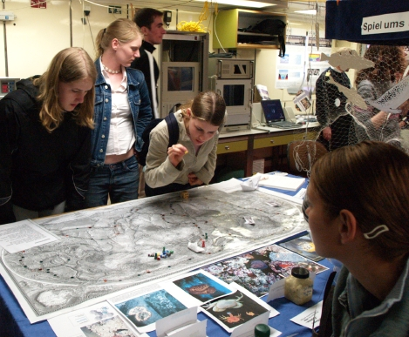
This project example from NaT-Working "Marine Research" at IFM-GEOMAR in Kiel, Germany, is an activity that does not require any major funding or elaborate material, but can nevertheless serve as a first step towards further collaborations. Since the partner school in this particular case was situated about one hour's drive away from the research institute, a project had to be devised that did not involve frequent vists at the institute but could take place mainly at the school. A group of students (biology A-level course) set themselves the task of designing a board game on ocean research which can be used as an educational game at home or as an interactive exhibit at open days both by the school and the research institute. The game uses the familiar mechanism of moving a pawn on a map and encountering events where the players are asked a quiz-question (on a topic from ocean sciences) before being allowed to continue. For several months, the students inquired into various ocean science topics to prepare the background for the quiz cards; they prepared (graded) presentations on their topics and discussed the material with their teacher and three ocean scientists. In addition, they wrote a (graded) glossary on the technical terms to explain why some answers in the quiz are correct and others are not. Although this project did not involve practical experiments, the students nevertheless obtained an impression of the innate interdisciplinarity of the research topics. The topics studied tied into the syllabus, both in biology and geography, and were part of a project-based teaching approach across disciplines. Interaction with the scientists mainly took place in the classroom during 2 or 3 afternoon visits over a 6 month period. Costs for the project (travel between the institute and the school, materials for the game) were almost negligible. The game has already been used at exhibitions (see figures) with great success.

Photo: test version of the game during an exhibition of the NaT-Working project onboard research vessel "ALKOR"

Freshwater ecology (Denmark)

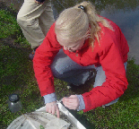Age group: 16
Subjects: Biology
School: Greve Gymnasium, Denmark
Research centre: A freshwater research centre in Denmark and local authorities

The students, a high school class of 26 students, doing obligatory biology, have been studying freshwater ecology in class. After a mainly textbook related study, the students have split up in small groups, and each group have defined and described the specific problem that they want to study in more detail. The assignment is to do practical field investigations that will allow the group to produce answers to the problem they want to investigate, and to write a report on their findings and the conclusions they draw. Finally each group must produce a small power point presentation to present to their class. This presentation should form the basis for some questions on for example environmental protection that they want the class to debate.

One group wanted to investigate the influence of enhanced levels of nitrate and phosphate on a small lake and to compare their findings with the water protection laws that the Danish Government has passed a few years ago.

The group first made an outline for their project and found reports on the internet on the water quality of the small lakes in their county. The Ph.D. students at the Freshwater Centre showed them how to examine the lakes for plants and animals and helped them to determine the species they found. They were also taught methods to measure the amount of oxygen, nitrate and phosphate in the water.

These methods were used on local lakes and the findings were compared to those of the county that regularily monitor the lakes, and finally the group asked their class to debate whether the water protection laws are adequate.

You can find many other examples on www.youngreporters.org (Young reporters for the environment)

Appendix 4. Examples of links between CarboEurope / CarboOcean science & syllabus
Curriculum/Syllabus
Science (14-18 years)
CarboEurope-Ocean
Topics/ Methods

- Biology
- Ecology
- Plant Physiology
- Biochemistry
- Microbiology
- Chemistry
- Equilibria
- Radical reactions
- Gas Phase reactions
- Thermodynamics
- Geography
- Climate(change/impact)
- Oceans
- Mathematics
- Statistics
- Differential equations
- Numerical methods/modelling
- Physics
- Energy production
- Optics
- Waves
- Isotopes

- Phytoplankton and carbon export
- Oceanic uptake: biological pump
- Terrestrial uptake (sequestration)
- Soil Respiration
- Gas exchange/fluxes
- Chemical buffers
- Purposeful carbon storage in the oceans
- Gas exchange ocean/atmosphere
- Ecosystem modeling
- Ocean circulations modeling
- Analysis of oceanographic data
- Global carbon cycle
- Global oxygen cycle
- Inventory of anthropogenic carbon in the oceans
- Oceanic measurements of carbon and oxygen
- Oceanic uptake: Physical pump
- Remote Sensing
- The marine CO₂ system
- ¹⁴C
Economics, Social Sciences, Languages, History, Ethics

