NADW transformation at the western boundary
between 66°W/20°N and 60°W/10°N

Reiner Steinfeldt, Monika Rhein, Maren Walter

The variability of North Atlantic Deep Water (NADW) properties in the western tropical Atlantic between 66°W/20°N and 60°W/10°N is investigated based on repeated hydrographic sections. The water at the western boundary carries a CFC maximum, indicating the direct transport of newly formed NADW within the Deep Western Boundary Current (DWBC) towards the tropics. The mean properties for the different NADW components reflect the changes in the water mass formation regions, especially the Labrador Sea. The greatest signal can be seen in the density range of the Labrador Sea Water (LSW), where a continuous freshening between 2000 and 2004 is observed. This is attributed to the arrival of low-salinity LSW formed in the Labrador Sea after 1988. In addition to the decreasing salinity in the LSW, the two lower NADW components also reveal a freshening trend, as has been observed in the subtropical and subpolar North Atlantic [Dickson et al., 2002. Rapid freshening of the deep North Atlantic Ocean over the past four decades. Nature 416, 832-837]. This tendency is not restricted to the boundary current region, but extends over the whole western tropical Atlantic. The spreading time of NADW from the Labrador Sea to the tropical Atlantic at 16N is estimated by the salinity signal to be 10-13 years, corresponding to a mean velocity of 2.0-2.5 cm/s. The dilution factor of NADW determined from the CFC difference between the Labrador Sea and the tropics is 4 to 5 for all components, assuming an admixture of old, CFC-free waters. The NADW properties at 16°N on isopycnals show large spatial variability along the section. At 10°N, the properties especially in the Upper NADW are horizontally homogenized. This is caused by the change of the shape of the continental slope, which is very steep at 16°N and gradually declining at 10°N, leading to a broadening of the upper portion of the boundary current between the two sections. The NADW at 10°N is a composite of the water from the western boundary at 16°N and about one third admixture of water from the interior. During the spreading from 16°N to 10°N, the uppermost portion of the ULSW becomes fresher and poor in CFCs by vertical mixing with the overlying Upper Circumpolar Deep Water (UCDW). The resulting diffusivity K_{ρ} is of the order of 10⁻⁴ m² s⁻¹.
The findings of this study concerning the spreading time of NADW from the subpolar to the tropical Atlantic is an important result for CARBOOCEAN. Some methods used to infer the concentration of anthropogenic carbon depend on the age of the water. Especially when inferring anthropogenic carbon from the the Transit Time Distribution (TTD) method, the TTDs for NADW should reflect the propagation time of salinity and CFC anomalies. The observed large dilution of NADW between 16°N and 10°N also effects the concentrations of anthropogenic carbon.

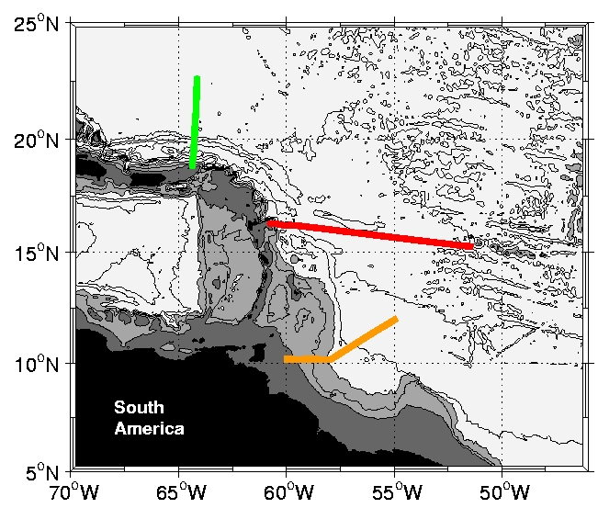
Map of the cruises in the western tropical Atlantic. The sections cross the Deep Western Boundary Current at 20°N along 64°W), at 16°N and 10°N. The isobaths are drawn each 1000 m, grey shading is for depth ranges 0--1000 m, 1000 m--3000 m and below 3000 m.

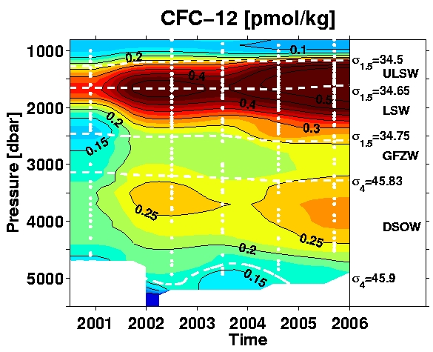 | 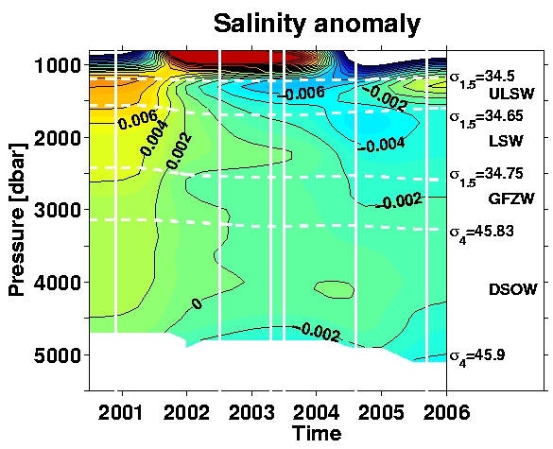
CFC-12 and salinity anomaly (isopycnal time-mean substracted) versus time for the boundary current region at 16°N. The components of North Atlantic Deep Water (NADW) from top to bottom are: Upper Labrador Sea Water (ULSW), Labrador Sea Water (LSW); Gibbs Fracture Zone Water (GFZW); Denmark Strait Overflow Water (DSOW).
The CFC increase is larger for ULSW/LSW than for GFZW/DSOW. This is ascribed to the arrival of the CFC-rich waters that have been formed in the Labrador Sea during the time period of extensive deep convection (1988-1994) at the 16°N section. The deep convection in the Labrador Sea is associated with a freshening of LSW, which can also be seen in the observations at 16°N. The spreading time of NADW from the Labrador Sea to the tropical Atlantic at 16°N can thus be estimated to 10-13 years. The salinity decrease of GFZW and DSOW reflects the longterm freshening trend of these water masses over the North Atlantic.

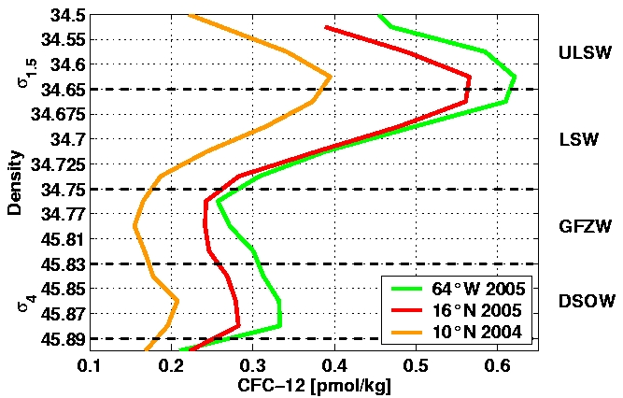
Mean CFC-12 profiles within the Deep Western Boundary Current (DWBC) at 64°W (around 20°N), 16°N and 10°N. Due to the spreading time between the sections (about 2 years from 66°W/20°N to 16°N and 1 year from 16°N to 10°N) and the diffderent time of sampling, the CFC concentration should decrease from section to section by a similar amount. The comparably large decrease between 16°N and 10°N can only be explained by the admixture of older, CFC-poor waters from the interior into the DWBC.

